
QUALITY ALERT

Customer: HPAC Date: December 16, 2018
Die: 15238 / 15191 / 15192 Colour: ALL
Type of Complaint: HPAC REJECTED

Q.A # Q.I.R # CUSTOMER NCR #

Description: HPAC Rejected due bending so they are unable to put the panels together.
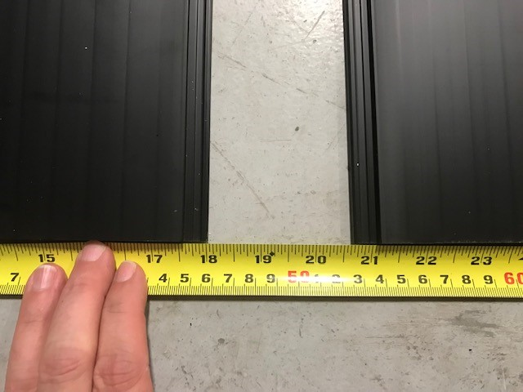
REJECTED SAMPLES
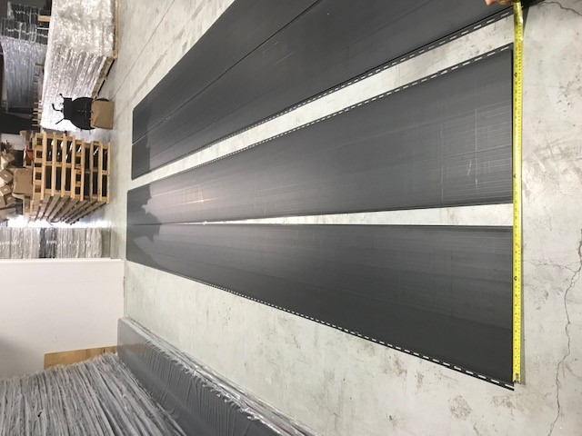

CHECK EVERY 3 HOURS WITH FULL LENGTH PIECES
CHECK 24 HOURS FOR EVERY WORK ORDER
BY SIGNING BELOW, YOU ACKNOWLEDGE THE PROBLEM ABOVE AND AGREE TO MONITOR THIS ISSUE IN FUTURE PRODUCTION RUNS.
DAY SHIFT |  | AFTERNOON SHIFT |  | NIGHT SHIFT
NAME | SIGNATURE | NAME | SIGNATURE | NAME | SIGNATURE

